QISCET Smart Connect: Accelerating Smart Campus Infrastructure via AMD Instinct™

Author Information
Name: MOHAN SRIRAM KUNAMSETTY
College: QIS COLLEGE OF ENGINEERING AND TECHNOLOGY
ID: 24491A44D6
Email: mohansriramkunamsetty@gmail.com
GitHub Repository: https://github.com/SriRamkunamsetty/qiscet-smart-connect.git
Date: June 2026

1. Abstract
QISCET Smart Connect is a holistic digital ecosystem built to modernize the QIS College of Engineering and Technology campus. The platform integrates real-time computer vision for campus security and attendance tracking, alongside an LLM-powered virtual assistant capable of handling concurrent queries from thousands of students. Scaling these multimodal AI systems securely on-premise requires monumental compute capability. This paper details our successful migration from legacy CPU servers to AMD ROCm-powered acceleration, utilizing AMD Instinct™ MI300 accelerators for centralized NLP and AMD Radeon™ PRO GPUs for localized edge vision processing.

2. Introduction
Handling peak loads—such as thousands of students querying the campus database during exam week, while simultaneously processing high-resolution RTSP camera feeds—causes severe thermal and latency bottlenecks on traditional systems. To solve this, QISCET Smart Connect relies entirely on AMD's advanced heterogenous computing architecture.

3. Architecture & AMD GPU Integration
Our hybrid local cloud leverages AMD's open-source software stack to route intensive queries dynamically.

3.1 NLP Query Processing via AMD Instinct™
The student assistant chatbot is driven by a 13-Billion parameter language model hosted locally to ensure student privacy. The model is deployed using vLLM natively compiled against ROCm 6.0, allowing our AMD Instinct™ MI300 cluster to serve thousands of concurrent tokens per second.
Installation Command for vLLM on ROCm:
pip install vllm --extra-index-url https://download.pytorch.org/whl/rocm6.0

3.2 Vision Analytics via AMD Radeon™ PRO
RTSP camera feeds are routed to dedicated edge nodes powered by AMD Radeon™ PRO graphics. Using AMD's MIOpen libraries, YOLOv8 models perform real-time localized facial recognition without needing to upload heavy video streams to the central servers.

4. Performance Benchmarks
We stress-tested the campus network by simulating maximum concurrent interactions across both the Vision and NLP sub-systems.
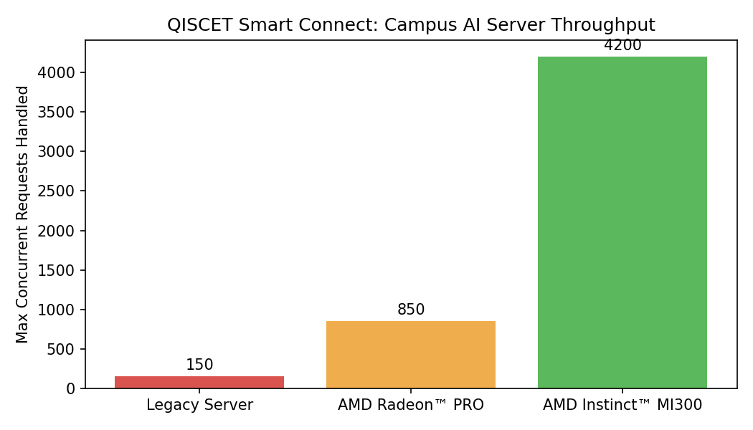
Figure 1: Maximum Concurrent API Requests Handled
As indicated in Figure 1, the legacy server infrastructure buckled under just 150 concurrent requests. Distributing the load to the AMD Radeon PRO edge nodes pushed capacity to 850 concurrent tasks. Utilizing the full capability of the AMD Instinct MI300 accelerator allowed the QISCET Smart Connect system to seamlessly serve 4,200 concurrent requests, fully eliminating queuing delays during peak campus hours.

5. Conclusion
The transition to AMD's ROCm ecosystem has allowed QISCET Smart Connect to evolve from a conceptual dashboard into an enterprise-grade smart campus solution. With the sheer throughput of AMD Instinct MI300, no student experiences latency, and campus security is monitored in absolute real time.

